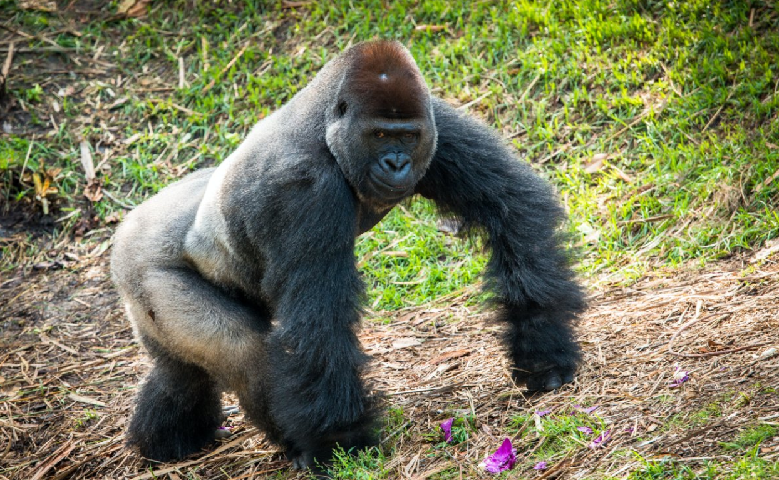

**Join the Houston Zoo’s 2019**

**Action for Apes Challenge**

**Answer the Call to Help Save Animals in the Wild!**

Dear Parent/Guardian,

We are very excited to be partnering with the Houston Zoo through the end of April 2019 in a recycling challenge called Action for Apes. We will be working hard to collect as many handheld electronic devices (like cellphones and tablets) as possible to be recycled through the Zoo. To win the challenge, we must recycle the most approved items* by April 30. We need your help!

Please assist in this challenge by working with family members to collect old cell phones which students can bring to school to be added to collection box. If we win, we will be the recipients of a one-of-a-kind painting to hang in our hallway, done by the Houston Zoo gorilla troop!

Why recycle your unused or old cell phones through Action for Apes? To help save animals like gorillas in the wild!

Cell phones and other handheld electronic devices contain a material called tantalum that is derived from the mineral Col-Tan (columbite-tantalite). Coltan is often destructively mined in Central Africa, which is home to many endangered species like chimpanzees, okapis, and gorillas. Recycling your old cell phones and other handheld electronic devices allows for tantalum to be reused, decreasing the need for mining – an action which ultimately helps to safe wildlife!

Please join us in our participation in the Action for Apes Challenge and help us reach our goal and become the 2019 winners!!

Thank you!



\**Cell phones, smart phones, iPods/MP3 players, iPads/tablets, WIFI hot spots, handheld gaming devices, and GPS count towards the challenge. Electronic accessories such as chargers, blue tooth headsets can be recycled but will not be counted towards challenge.*